|  |  |  |  |  |
| --- | --- | --- | --- | --- |
|  |  | | |  |
|  |  | | |  |
|  | Drive Control Optimization Experience | | |  |
|  | (F004530-Drive Control Optimization) | | |  |
|  |  | | |  |
|  |  | | |  |
| Document Type | **Aggregated Feature Specification** | | |  |
| Template Version | **6.0c** | | |  |
| Document ID | **F004530** | | |  |
| Document Location |  | | |  |
| Document Owner | **Lucian Vacarescu <** [lvacares@ford.com](mailto:lvacares@ford.com)**>,**  **Hua Lin <**hlin48@ford.com**>** | | |  |
| Document Revision | **A** | | |  |
| Document Status | **1** | | |  |
| Date Issued | **05.14.2021** | | |  |
| Date Revised |  | | |  |
| Document Classification | GIS1 Item Number: | **N/A** | |  |
| GIS2 Classification: | **Confidential** | |
|  | | | | |
|  | | | | |
| Document Approval | | | | |
| Person | Role | | Email Confirmation | Date |
| Lisa Waszczenko | Feature Owner Supervisor | | Lfuller2@ford.com | 5/25/2021 |
| Damiete Samuel-Horsfall | Model Architect | | dsamuelh@ford.com | 5/25/2021 |

Printed Copies Are Uncontrolled

# Disclaimer

**This document contains Ford Motor Company Confidential information. Disclosure of the information contained in any portion of this document is not permitted without the expressed, written consent of a duly authorized representative of Ford Motor Company, Dearborn, Michigan, U.S.A.**

**Copyright, Ó 2016 Ford Motor Company**

This document contains information developed and accumulated by and for FORD MOTOR COMPANY. As such, it is a proprietary document, which, if disseminated to unauthorized persons, would provide others with restricted information, data, or procedures not otherwise available, exposing the FORD MOTOR COMPANY to potential harm.

Employees and suppliers having custody of this specification or authorized to use it must be cognizant of its proprietary nature and ensure that the information herein is not made available to unauthorized persons.

FORD MOTOR COMPANY reserves the right to protect this work as an unpublished copyrighted work in the event of an inadvertent or deliberate unauthorized publication. FORD MOTOR COMPANY also reserves its rights under copyright laws to protect this work as a published work.

This document or portions thereof shall not be distributed outside FORD MOTOR COMPANY without prior written consent. Refer all questions concerning disclosure to the author(s) or to any duly authorized representative of Ford Motor Company.

# Contents

Disclaimer 2

Contents 3

1 INTRODUCTION 6

1.1 Document Purpose 6

1.2 Document Scope 6

1.3 Document Audience 6

1.3.1 Stakeholder List 6

1.4 Document Organization 7

1.4.1 Document Context 7

1.4.2 Document Structure 7

1.5 Document Conventions 7

1.5.1 Requirements Templates 7

1.5.1.1 Identification of requirements 7

1.5.1.2 Requirements Attributes 7

2 Feature DOCUMENT 8

2.1 Feature Overview 8

2.1.1 Feature Purpose and Description 8

2.1.2 Vehicle Entry Behavior 8

2.1.3 Vehicle Exit Behavior 8

2.1.4 Feature Variants 9

2.1.5 Regions & Markets 9

2.1.6 Assumptions 9

2.1.7 References 9

2.1.7.1 Ford documents 9

2.1.7.2 External documents and publications 10

2.1.8 Glossary 10

2.1.8.1 Abbreviations 10

2.2 Feature Context 11

2.2.1 Feature Context Diagram 11

2.2.2 List of Influences 13

2.3 Feature Modeling 14

2.3.1 Operation Modes and States 14

2.3.2 Use Cases 17

2.3.2.1 Use Case Diagram 17

2.3.2.2 Actors 18

2.3.2.3 Use Case Descriptions 18

2.4 Feature Requirements 25

2.4.1 Functional Requirements 25

2.4.1.1 Error Handling 25

2.4.2 HMI Requirements 25

2.4.3 Other Requirements 25

3 FUNCTIONAL ARCHITECTURE 26

3.1 Description 26

3.2 Function List 26

3.3 Signal List 26

4 FUNCTION SPECIFICATIONS 28

4.1 Logical Function “Drive Control Optimization” 28

4.1.1 Function Overview 28

4.1.1.1 Description 28

4.1.1.2 Assumptions 28

4.1.2 Function Scope 28

4.1.3 Function Interfaces 28

4.1.4 Function Modeling 28

4.1.4.1 Use Cases 28

4.1.4.2 State Charts / Activity Diagrams / Sequence Diagrams / Decision Tables 28

*4.1.5* Function Requirements 28

4.1.5.1.1 Normal Operation 28

4.2 Logical Function “Drive Control Optimization” 33

4.2.1 Function Overview 33

4.2.1.1 Description 33

4.2.1.2 Assumptions 33

4.2.2 Function Scope 33

4.2.3 Function Interfaces 33

4.2.4 Function Modeling 33

*4.2.5* Function Requirements 33

4.2.5.1.1 Normal Operation 33

4.3 Logical Function “DCO” 33

4.3.1 Function Overview 33

4.3.1.1 Description 33

4.3.1.2 Assumptions 33

4.3.2 Function Scope 33

4.3.3 Function Interfaces 34

4.3.3.1 Logical Inputs 34

4.3.3.2 Logical Outputs 34

4.3.4 Function Modeling 34

4.3.4.1 Use Cases 34

4.3.4.2 State Charts / Activity Diagrams / Sequence Diagrams / Decision Tables 34

*4.3.5* Function Requirements 34

4.3.5.1.1 Normal Operation 34

4.4 HMI Function “refer to BPTS and AEIS (DSIS) feature documents” 34

4.4.1 Function Overview 34

4.4.1.1 Description 34

4.4.2 Function Scope 34

4.4.3 Function Interfaces 34

4.4.3.1 State Charts / Activity Diagrams / Sequence Diagrams / Decision Tables 34

5 Feature IMPLEMENTATION SPECIFICATION 35

5.1 Feature Implementation Overview 35

5.1.1 Description 35

5.1.2 Assumptions 35

5.1.2.1.1 E/E Architecture 35

5.1.2.2 E/E Components 35

5.1.2.3 E/E Connections 35

5.1.2.4 Signal List 35

5.2 Function Deployment 35

5.2.1 Function Allocation 35

5.3 Requirements 35

5.3.1 Requirements on Components 35

5.3.1.1 Component 35

5.3.1.2 Inputs 37

5.3.1.3 Logical Outputs 37

5.3.1.4 Component 37

5.3.1.5 Logical Inputs 37

5.3.1.6 Logical Outputs 37

5.3.2 Requirements on Connections 37

6 OPEN CONCERNS 38

7 REVISION HISTORY 39

8 APPENDIX 40

**List of Figures**

Figure 1: DCO Context Diagram 11

Figure 3: DCO Use Case Diagram 17

**List of Tables**

Table 1: Feature Variants 9

Table 2: Ford Documents 10

Table 3: External documents and publications 10

Table 4: Abbreviations used in this document. 10

Table 5: List of impact features 12

Table 5: List of Influences 14

Table 6: Operation Modes 16

Table 7: Transition between Operational States 16

Table 8: List of Actors 18

Table 11: E/E Connections 35

Table 12: Open Concerns 38

# INTRODUCTION

## Document Purpose

The Aggregated Feature Specification (AFS) specifies a Feature from Feature level (customer & market perspective) down to Component level on an electrical platform.

The 3 chapters:

* Feature Document
* Function Specifications
* Feature Implementation Specification

correspond to the 3 levels of the RE Information Model - Feature Level, Function Level, and Component Level (cross-ECU/platform view only). The AFS requirements are cascaded to the ECU Functional Specs on Component Level.

## Document Scope

The following and its deployment to the electrical architecture is described in this :

* Drive Control Optimization

## Document Audience

The is authored by Lisa Waszczenko. All Stakeholders, i.e., all people who have a valid interest in the feature behavior should read and, if possible, review the . It needs to be guaranteed, that all stakeholders have access to the currently valid version of the .

### Stakeholder List

For the latest list of the stakeholders and their roles & responsibilities refer to <Put VSEM Link here>.

|  |  |  |
| --- | --- | --- |
| **Name** | **CDSID** | **Role** |
| Lisa Waszczenko | LFULLER2 | Feature Owner Supervisor |
| Lucian Vacarescu | LVACARES | Feature Owner |
| Hua Lin | HLIN48 | Feature Owner |
| Venkateshwar Rao Muttineni | VMUTTINE | Pre-Feature Owner |
| Michael Hrecznyj | MHRECZNY | Pre-Feature System Engineer |
| Patrick Brautigan (P.) | PBRAUTIG | CIED |
| Christopher Henderson | CHENDE63 | Pre-Feature Supervisor |
| Fernando Sarracini | FSARRACI | Feature Owner Supervisor |
| Wander Cristiano | WCRISTIA | Feature Owner |
| CP Engelbrecht | CENGELB5 | Feature Owner |
| Paul Braithwaite | PBRAITH1 | PCCN Vehicle Features and Engine Starting Systems Supervisor |
| Reace Head |  |  |
| David Treham |  |  |

## Document Organization

### Document Context

Refer to the [Ford RE Wiki](http://wiki.ford.com/display/RequirementsEngineering/Requirements+Engineering+for+SW+Enabled+Features) to get more information about the different Requirements Engineering (RE) templates (and how the relates to those) and the overall RE approach for SW-enabled Features.

### Document Structure

The structure of this document is explained below:

**Section 1** – Introduction how to use this document including responsibilities and requisite documents. Explains the terminology. Gives a clarification of the definitions, concepts and abbreviations used in the document.

**Section 2** – Document. Defines the Feature level requirements of the realized by the system described in this specification

**Section 3** – Functional Architecture: Specifies the functional decomposition of the .

**Section 4** – Function Specifications: Specifies the Logical Functions of the functional architecture of the .

**Section 5** – Implementation Specification: Specifies details of how the / Logical Functions are deployed to the given electrical platform.

**Section 6** – List Open Concerns

**Section 7** Revision History.

**Section 8** – Appendix (Data Dictionary, etc.)

## Document Conventions

### Requirements Templates

Each requirement, use case or scenario in this specification shall follow the corresponding template given in the document template *Specification_Macros.dotm* at [RE Wiki - Specification Templates](http://wiki.ford.com/display/RequirementsEngineering/Specification+templates?src=contextnavpagetreemode).

#### Identification of requirements

The unique requirement ID given in the headline of any requirement follows the requirement throughout the development process. The requirement ID format follows a well-defined syntax.

All identifiers in this specification shall be composed of 4 parts:

* A leading prefix, which indicates the type of requirement (R=Requirement, UC=Use Case, SC=Scenario, …)
* A prefix, which indicates the abstraction level (F=Feature, FNC=Function, CMP = component).
* Followed by a name, indicating the scope, which the requirement belongs to (e.g. feature or function name)
* Ending with the actual requirement number

*Example:*

*R_CMP_LockArbitrator_00004* This is the fourth requirement on component level for the function Lock Arbitrator.

#### Requirements Attributes

The templates provided by *Specification_Macros.dotm* define a list of attributes for each requirement. This helps to classify the requirement. The attributes are explained at [RE Wiki - Requirements Attributes](http://wiki.ford.com/display/RequirementsEngineering/Requirements+Attributes?src=contextnavpagetreemode).

# Feature DOCUMENT

## Overview

### Feature Purpose and Description

Drive control optimization reduces the vehicles operational reliance on single-purpose interfaces, such as push-to-start and electronic park brake switches. In the case of power-state-control, the functionality that is typically associated with the push-to-start switch has been distributed across several vehicle triggers, such as transmission, seatbelt, and “key” location status, to determine when the user desires the vehicle to be “on” or “off”.

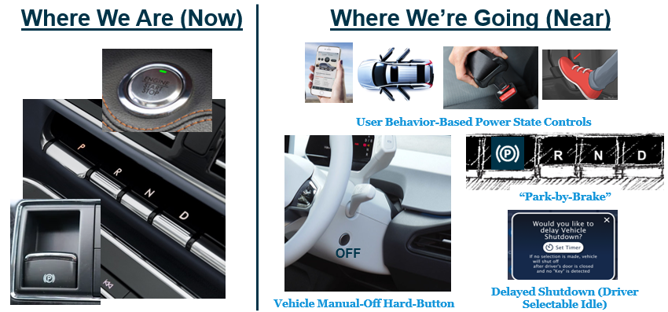



DCO experience cascades functions and use cases to Buttonless Push to Start feature and AEIS (DSIS) feature.

### Vehicle Entry Behavior

When entering the vehicle using a far-field communication (FFC) “key”, the vehicle turns “on” (HV On Mode) automatically when the driver’s door closes and an authorized “key” is detected in the passenger compartment. When in HV On Mode, all vehicle functionality, with the exception of vehicle propulsion, is available to user. After entering, when the user presses the brake pedal, the driver’s seat transitions from an easy entry/easy exit position into the driving position associated with the “key” brought into the vehicle by the user. Vehicle propulsion becomes available to the user once they place their foot on the brake and select a desired drive range (i.e. Drive or Reverse). In the event that the driver’s door does not transition to closed (or any other situation where the vehicle is not on), a brake pedal apply will also transition the vehicle into a HV On Mode, as long as a valid “key” is present.

### Vehicle Exit Behavior

When the driver places the vehicle in “park” and removes their seatbelt, the vehicle drive-cycle summary will be displayed on the instrument cluster portion of the high-head-down display and the AEIS Driver Selectable Idle (DSI) menu shall be offered on the vehicle centerstack display. If the user ignores the DSI menu and proceeds to exit the vehicle with their “key”, the vehicle will shutdown once the driver’s door transitions to closed. If the user interacts with the DSI menu, they will have the option of delaying the vehicle shutdown for a configurable period of time or may choose to delay the vehicle shutdown indefinitely. Once the user activates the DSI delayed shutdown system, the default delay setting will be the last configuration used and start counting down after the driver’s door transitions to closed and no “key” is detected in the passenger compartment. If the indefinite shutdown delay option is selected, the vehicle will remain in the HV On Mode until a high-voltage traction battery low state-of-charge (SoC) threshold is reached or until the user disables the DSI delayed shutdown system.

### Variants

|  |  |  |
| --- | --- | --- |
| Variant Name | Variant Description | Remarks |
| **BEV** | **BEV – Battery Electric Vehicle** |  |
| **Keyless** | Standard 30minute Max Idle Timer for all pushbutton start vehicles | Applicable for all powerpacks |
| **Driver Selectable Idle for Fleet (Keyed/Keyless)** | Provides HMI for a 1 to 30 minute Idle Timer available to Fleet customers. | Applicable for all powerpacks for fleet vehicles (generally CV/Truck) |
| **Driver Selectable Idle for Buttonless Start** | Provides Buttonless Start vehicles HMI to extend the vehicle idle so the vehicle does not shutdown immediately when the driver exits with the key. | Applicable for BEV only |

Table 1: Feature Variants

### Regions & Markets

|  |  |  |  |  |  |  |
| --- | --- | --- | --- | --- | --- | --- |
| **Market /**  **Region**  Variant Name | **North America** | **South America** | **Europe** | **MiddleEast/Africa** | **Asia / Pacific** | **China** |
| **Standard** | *YES* |  |  | *YES* | *YES* | *YES* |
| **BEV** | Mandatory | No | Mandatory | No | No | Mandatory |

### Assumptions

* Require FNV3 Architecture
* Require Gen 2 BCM
* Require BEV
* Require vehicle to be equipped with E-Latch, PaaK, NFC, Park-by-Brake
* Require Phoenix domain for APIM HMI
* Require OFF button for safety
* Require Non-ESCL (Electric Steering Column Locker)

### References

#### Ford documents

List here all Ford internal documents, which are directly related to the feature.

|  |  |  |  |
| --- | --- | --- | --- |
| **Reference** | **Doc. ID** | **Title** | **Revision** |
| **???** | ffst01.10_featuredocument_sysmlreporttemplate | Buttonless Push to Start Feature Document | **???** |
|  | dsi feature document_v1.docx | AEIS (DSIS) Feature Document |  |

Table 2: Ford Documents

#### External documents and publications

The list of external documents should include e.g. relevant standards.

|  |  |  |  |
| --- | --- | --- | --- |
| **Reference** | **Doc. ID** | **Title** | **Revision** |
|  |  | ISO 26262 related to DCO experience |  |
|  |  | FMVSS-108 |  |
|  |  |  |  |

Table 3: External documents and publications

### Glossary

#### Abbreviations

|  |  |  |
| --- | --- | --- |
| Abbr. | Stands for | Description |
| AFS | Aggregated Feature Spec | Comprehensive featured document |
| ARL | Attribute Requirements List | Attribute Requirements List |
| DDM | Driver Door Module | Module that communicates information about the driver door |
| Paak | Phone as a Key |  |
| IPC | Instrument Panel Cluster | HMI for the doors off feature. Displays messages to customer |
| ECG | Enhanced Central Gateway | Passes information from different buses on the vehicle |
| NVM | Non Volatile Memory | Memory Storage. |
| DCU | Door Control Unit | Comprehensive name for all Door control modules |

Table 4: Abbreviations used in this document.

## Feature Context

### Feature Context Diagram

DCO experience mostly cascade to BPTS and AEIS (DSIS) features. Refer to BPTS and AEIS (DSIS) feature documents.

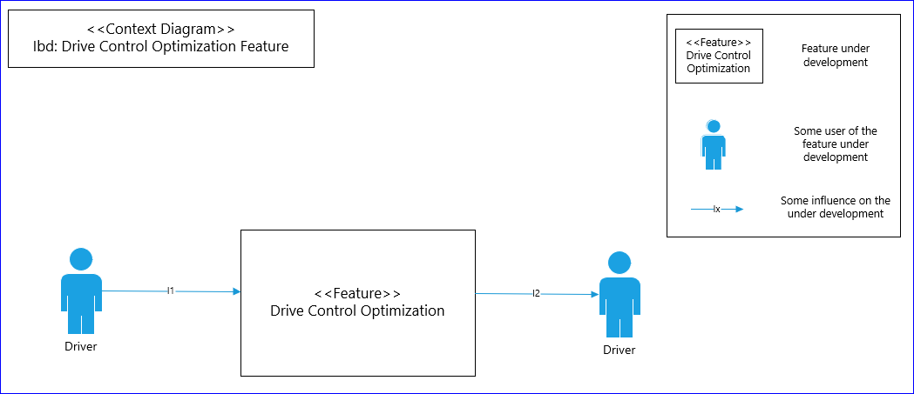

Figure 1: DCO Context Diagram

DCO experience impact the following features by signals changes and modifications from BPTS and AEIS (DSIS).

|  |  |  |
| --- | --- | --- |
| **No.** | **Feature Name** | **Description** |
|  |  |  |
| 1 | Classic Memory (EE/EE) |  |
| 2 | Ford Welcome / Farewell |  |
| 3 | Global Beltminder |  |
| 4 | Lincoln Embrace |  |
| 5 | NFC Entry and Ignition |  |
| 6 | PDLC Skylight Digital Shade |  |
| 7 | Perimeter Anti-Theft Alarm |  |
| 8 | Power Central Lock Suite |  |
| 9 | Pro Power Onboard |  |
| 10 | Rear Seat Occupant Alert |  |
| 11 | Remote Park Assist |  |
| 12 | Thermal Management Optimization Strategy (Climate) |  |
|  |  |  |
|  |  |  |
|  |  |  |
|  |  |  |

Table 5: List of impact features

### List of Influences

|  |  |  |
| --- | --- | --- |
| **ID** | **External Entity** | **Influence Description** |
| Access Vehicle | User To Buttonless Start | User entering the vehicle |
| Brake Status | Brake Status Provider To Buttonless Start | Brake press information |
| Car Mode | Special Manufacturing Mode To Buttonless Start | Car modes: normal, transport, factory |
| Door Status | Closures Status Provider To Buttonless Start | Door switch information |
| eShift Status | eShifter Status Provider To Buttonless Start | Shifter position information |
| Feedback | HMI - IPC To User | HMI messages, instructions, indications |
| HV Battery Status | High Voltage Battery Manager To Buttonless Start | HV contactors status |
| HV Contactors command | Buttonless Start To High Voltage Battery Manager | HV contactors status |
| IGN ON / OFF Request | Buttonless Start To Ignition Manager | Ignition request: IGN ON = ISPR ON, IGN OFF = ISPR OFF |
| Ignition Status | Ignition Manager To Buttonless Start | Ignition status on CAN |
| Inhibit Request | Start Inhibit Provider To Buttonless Start | Inhibit request like Immobilizer, OTA etc |
| Key Status | Detected Key Status Provider To Buttonless Start | Key status: detected or not detected inside the vehicle |
| Key Type Information | Key Type Provider To Buttonless Start | Key type: NFC, PaaK |
| Provide Feedback | Buttonless Start To HMI - IPC | Messages and indications request to HMI. |
| Regulation | Regulations / Standards To Buttonless Start | Legal requirements (if applied) |
| Remote Start Request | Remote Start Status Provider To Buttonless Start | Remote Start request. |
| Shutdown Request | External Shutdown Requester To Buttonless Start | External shutdown request like AEIS/DSIS. |
| Speed Status | Vehicle Speed Status Provider To Buttonless Start | Vehicle speed information |
| Start/Stop Button Status | Start/Stop Button Status Provider To Buttonless Start | Start/Stop button information if pressed or not. |
| Torque Availability | PT Torque Manager To Buttonless Start | Torque availability status. Torque ON / OFF (Available / Not Available) |
| Torque ON/OFF Request | Buttonless Start To PT Torque Manager | Torque request. |
| Transmission Gear Command | Buttonless Start To Transmission Manager | Engage gear. |
| Transmission Status | Transmission Manager To Buttonless Start | Transmission gear position status. |
| Cluster Messages | HMI To Automatic Engine Idle Shutdown (AEIS) |  |
| Disable Requests | Disable Requests To Automatic Engine Idle Shutdown (AEIS) |  |
| Pedal States | Pedal States To Automatic Engine Idle Shutdown (AEIS) |  |
| Powerpack State | Powerpack State To Automatic Engine Idle Shutdown (AEIS) |  |
| Shutdown Engine | Automatic Engine Idle Shutdown (AEIS) To |  |
| Transmission State | Transmission State To Automatic Engine Idle Shutdown (AEIS) |  |
| Vehicle Operator | Vehicle Operator To Automatic Engine Idle Shutdown (AEIS) |  |
| Vehicle Speed | Vehicle Speed To Automatic Engine Idle Shutdown (AEIS) |  |

Table 5: List of Influences

## Feature Modeling

### Operation Modes and States

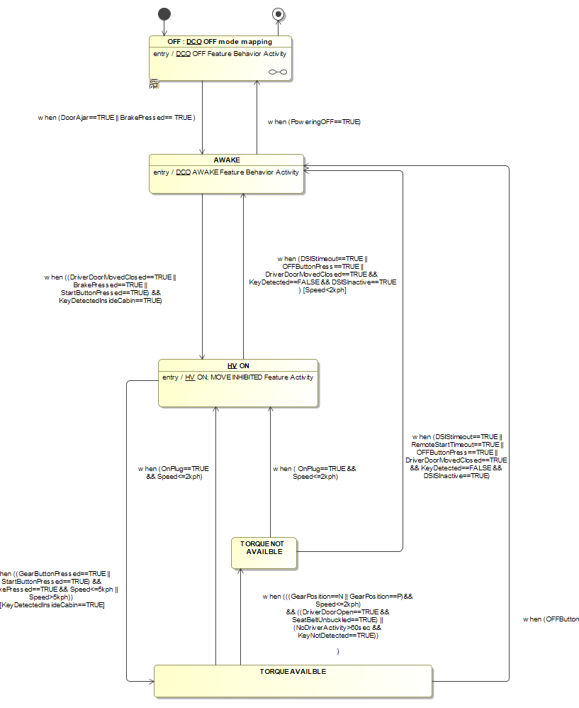

Figure 2: DCO State Machine

Refer to BPTS and DSIS state diagram in BPTS and DSIS feature documents.

|  |  |  |
| --- | --- | --- |
| **State** | **Description** | **Requirements Reference** (optional) |
| DCO OFF Mode | Ignition_Stattus==OFF  PwPckOFF_TqNotAvailable  HV OPEN |  |
| AWAKE | Ignition_Stattus==OFF  PwPckOFF_TqNotAvailable  HV OPEN |  |
| HV ON | Ignition_Stattus==RUN  PwPckOFF_TqNotAvailable  HV CLOSED |  |
| TORQUE NOT AVAILABLE | Ignition_Stattus==RUN  PwPckOFF_TqNotAvailable  HV CLOSED |  |
| TORQUE AVAILABLE | Ignition_Stattus==RUN  PwPckON_TqAvailable  HV CLOSED |  |
|  |  |  |
|  |  |  |
|  |  |  |

Table 6: Operation Modes

|  |  |  |  |  |
| --- | --- | --- | --- | --- |
| **Transition ID** | **Source** | **Destination** | **Description** | **Requirements Reference**  (optional) |
| T1 | VEHICLE OFF | AWAKE |  |  |
|  |  |  |  |  |
|  |  |  |  |  |
|  |  |  |  |  |
|  |  |  |  |  |
|  |  |  |  |  |
|  |  |  |  |  |
|  |  |  |  |  |
|  |  |  |  |  |

Table 7: Transition between Operational States

### Use Cases

#### Use Case Diagram

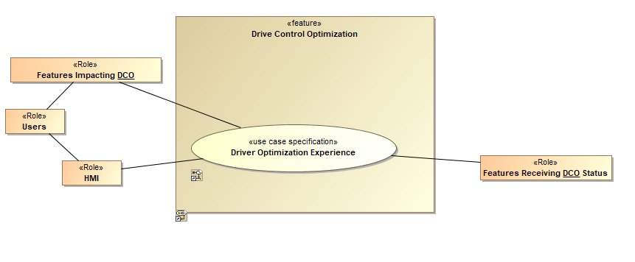

Figure 3: DCO Use Case Diagram

#### Actors

| Actor | Description |
| --- | --- |
| Brake Status Provider | Brake press information |
| Closures Status Provider | Door switch status |
| Detected Key Status Provider | Key detected or not detected inside the vehicle |
| eShifter Status Provider | Gear shift position status |
| HMI - IPC | Message center (IPC) |
| Ignition Manager | Ignition status (RUN, Start, OFF) and command. |
| PT Torque Manager | Modules (hardware / software) responsible to make propulsive torque available (motive mode ON) |
| User | Driver |
| Vehicle Speed Status Provider | Vehicle Speed information |

Table 8: List of Actors

#### Use Case Descriptions

DCO use case are cascaded from DCO ARL. The following are use cases aligned with other features:

###UC_F_DCO_00001### User enter locked vehicle through driver’s door with authorized far-field-communication “key”

|  |  |  |
| --- | --- | --- |
| **Purpose** |  | Driver enter locked vehicle by authorized far-field-communication “key” |
| **Actors** |  | Vehicle driver |
| **Precondition** |  | Driver door locked |
|  |  |  |
| **Main Flow** | M1 | Authorized far-field-communication “key” detected. |
|  | M2 | Authorized far-field-communication “key” unlock driver door. |
|  | M3 | Welcome feature start when driver sit in driver seat. |
| **Alternative Flow 1** |  |  |
|  |  |  |
| **Alternative Flow 2** |  |  |
|  |  |  |
| **Post-condition** |  |  |
| **Exceptions** |  |  |

###UC_F_DCO _00002### User transitions vehicle into a motive mode with an authorized far-field-communication “key”

|  |  |  |
| --- | --- | --- |
| **Purpose** |  | Driver transition vehicle into a motive mode with an authorized far-field-communication “key” |
| **Actors** |  | Vehicle driver |
| **Precondition** |  | Driver sit in the vehicle |
|  |  | Vehicle in HV ON mode state |
| **Main Flow** | M1 | Authorized far-field-communication “key” detected |
|  | M2 | Driver presses the brake pedal and selects a drive range (Drive, Reverse) |
|  | M3 | Vehicle transitions into a motive mode |
| **Alternative Flow 1** |  |  |
|  |  |  |
| **Alternative Flow 2** |  |  |
|  |  |  |
| **Post-condition** |  |  |
| **Exceptions** |  |  |

###UC_F_DCO_00003### User entering vehicle through non-driver’s door with authorized far-field-communication “key”

|  |  |  |
| --- | --- | --- |
| **Purpose** |  | Driver enter vehicle through non-driver’s door with authorized far-field-communication “key” |
| **Actors** |  | Vehicle driver |
| **Precondition** |  | Driver’s door closed. |
|  |  |  |
| **Main Flow** | M1 | Authorized far-field-communication key detected. |
|  | M2 | Vehicle doors except driver’s door unlock |
|  | M3 | Vehicle driver enter vehicle through non-driver’s door. |
| **Alternative Flow 1** |  |  |
|  |  |  |
| **Alternative Flow 2** |  |  |
|  |  |  |
| **Post-condition** |  |  |
| **Exceptions** |  |  |

###UC_F_DCO_00004### User with authorized far-field-communication “key” turns vehicle on manually

|  |  |  |
| --- | --- | --- |
| **Purpose** |  | Driver turn on vehicle by authorized far-field-communication “key” |
| **Actors** |  | Vehicle driver |
| **Precondition** |  | Vehicle status is OFF, valid “key” detected by vehicle |
|  |  | Driver sit in driver’s seat. |
| **Main Flow** | M1 | Driver press the brake pedal |
|  | M2 | Vehicle transition to HV ON mode state |
|  | M3 |  |
| **Alternative Flow 1** |  |  |
|  |  |  |
| **Alternative Flow 2** |  |  |
|  |  |  |
| **Post-condition** |  |  |
| **Exceptions** |  |  |

###UC_F_DCO_00005### User with authorized near-field-communication “key” unlocks and “starts” vehicle within authorization time window

|  |  |  |
| --- | --- | --- |
| **Purpose** |  | Driver presses brake pedal within the NFC unlock authorization window |
| **Actors** |  | Vehicle driver |
| **Precondition** |  | Vehicle doors locked. |
|  |  | Driver presses brake pedal within NFC start authorization time window |
| **Main Flow** | M1 | Vehicle driver unlocks vehicle doors by the exterior NFC reader |
|  | M2 | Vehicle driver enter vehicle and press brake pedal within NFC unlock authorization time window |
|  | M3 | Vehicle transition to HV ON mode state |
| **Alternative Flow 1** |  |  |
|  |  |  |
| **Alternative Flow 2** |  |  |
|  |  |  |
| **Post-condition** |  |  |
| **Exceptions** |  |  |

###UC_F_DCO_00006### User with authorized near-field-communication “key” unlocks and “starts” vehicle outside the authorization time window

|  |  |  |
| --- | --- | --- |
| **Purpose** |  | Vehicle driver enter vehicle with NFC and press brake pedal after the authorization time window to start vehicle. |
| **Actors** |  | Vehicle driver |
| **Precondition** |  | Vehicle doors locked. |
|  |  | Vehicle is in OFF mode. |
| **Main Flow** | M1 | Driver enter vehicle by NFC and sit in driver’s seat. |
|  | M2 | Driver press brake pedal after the authorization time window to start vehicle. |
|  | M3 | Vehicle transition to HV ON mode state |
| **Alternative Flow 1** |  |  |
|  |  |  |
| **Alternative Flow 2** |  |  |
|  |  |  |
| **Post-condition** |  |  |
| **Exceptions** |  |  |

###UC_F_DCO_00007### User with authorized near-field-communication “key” unlocks the vehicle

|  |  |  |
| --- | --- | --- |
| **Purpose** |  | Driver unlock vehicle with NFC “key” |
| **Actors** |  | Vehicle driver |
| **Precondition** |  | Vehicle doors locked. |
|  |  |  |
| **Main Flow** | M1 | Driver scan NFC “key” on NFC reader (near the driver’s door) to unlock the vehicle. |
|  | M2 | NFC start authorization time window after NFC “key” scan on NFC reader. |
|  | M3 |  |
| **Alternative Flow 1** |  |  |
|  |  |  |
| **Alternative Flow 2** |  |  |
|  |  |  |
| **Post-condition** |  |  |
| **Exceptions** |  |  |

###UC_F_DCO_00008### User enters unlocked vehicle and starts the vehicle using an authorized near-field-communication “key”

|  |  |  |
| --- | --- | --- |
| **Purpose** |  | Driver enter unlocked vehicle and start the vehicle by an authorized NFC “key” |
| **Actors** |  | Vehicle driver |
| **Precondition** |  | Vehicle is unlocked. |
|  |  |  |
| **Main Flow** | M1 | Driver scan NFC “key” on the interior NFC reader |
|  | M2 | Driver press a vehicle-on trigger (brake pedal) |
|  | M3 | Vehicle transition to HV ON Mode state and may be transitioned to motive mode. |
| **Alternative Flow 1** |  |  |
|  |  |  |
| **Alternative Flow 2** |  |  |
|  |  |  |
| **Post-condition** |  |  |
| **Exceptions** |  |  |

###UC_F_DCO_00009### User exiting vehicle, with authorized “key”, through driver’s door. (automatic shutdown)

|  |  |  |
| --- | --- | --- |
| **Purpose** |  | Driver exit vehicle by driver’s door with authorized “key”. |
| **Actors** |  | Vehicle driver |
| **Precondition** |  | Vehicle is in park status. |
|  |  |  |
| **Main Flow** | M1 | The driver’s door transition to close and no authorized “key” is detected in the passenger compartment. |
|  | M2 | Vehicle automatically shut down. |
|  | M3 |  |
| **Alternative Flow 1** |  |  |
|  |  |  |
| **Alternative Flow 2** |  |  |
|  |  |  |
| **Post-condition** |  |  |
| **Exceptions** |  |  |

###UC_F_DCO_000010### User shuts vehicle down by pressing the vehicle-off switch while vehicle is stationary (manual shutdown)

|  |  |  |
| --- | --- | --- |
| **Purpose** |  | Driver shut down vehicle by pressing the vehicle-off switch. |
| **Actors** |  | Vehicle driver |
| **Precondition** |  | Vehicle is stationary. Vehicle speed is below 5 kph. |
|  |  |  |
| **Main Flow** | M1 | Driver press vehicle-off switch. |
|  | M2 | Vehicle shut down. |
|  | M3 |  |
| **Alternative Flow 1** |  |  |
|  |  |  |
| **Alternative Flow 2** |  |  |
|  |  |  |
| **Post-condition** |  |  |
| **Exceptions** |  |  |

###UC_F_DCO_000011### User deactivates powertrain by pressing the vehicle-off switch while vehicle is in motion (manual shutdown)

|  |  |  |
| --- | --- | --- |
| **Purpose** |  | Driver deactivate powertrain by pressing the vehicle-off switch. |
| **Actors** |  | Vehicle driver |
| **Precondition** |  | Vehicle speed is above 5 kph. |
|  |  |  |
| **Main Flow** | M1 | Driver press vehicle-off switch. |
|  | M2 | Powertrain is deactivated. |
|  | M3 | When vehicle speed is below 5 kph, vehicle shift to “park” and HV contactors transition to open. |
| **Alternative Flow 1** |  |  |
|  |  |  |
| **Alternative Flow 2** |  |  |
|  |  |  |
| **Post-condition** |  |  |
| **Exceptions** |  |  |

###UC_F_DCO_000012### User reactivates powertrain by selecting a drive range on vehicle transmission shift interface

|  |  |  |
| --- | --- | --- |
| **Purpose** |  | Driver reactivate powertrain |
| **Actors** |  | Vehicle driver |
| **Precondition** |  | Vehicle speed is above 5 kph. |
|  |  | Driver has deactivated vehicle powertrain. |
| **Main Flow** | M1 | Vehicle gear is in “neutral” status. |
|  | M2 | Driver select a drive range on transmission shift interface (i.e. Drive or Reverse gear). |
|  | M3 | Vehicle shifts to selected gear and returns to normal driving behavior. |
| **Alternative Flow 1** |  |  |
|  |  |  |
| **Alternative Flow 2** |  |  |
|  |  |  |
| **Post-condition** |  |  |
| **Exceptions** |  |  |

###UC_F_DCO_000013### User with authorized “key” idles vehicle while in “park” (Standard AEIS)

|  |  |  |
| --- | --- | --- |
| **Purpose** |  | Driver idle vehicle while in “park”. |
| **Actors** |  | Vehicle driver |
| **Precondition** |  | Vehicle in “park” status. |
|  |  |  |
| **Main Flow** | M1 | No further action is taken (brake pedal press, accelerator pedal press, deactivation of AEIS) by user. |
|  | M2 | Vehicle idle for 30 minutes (default setup) before automatically shut down. |
|  | M3 |  |
| **Alternative Flow 1** |  |  |
|  |  |  |
| **Alternative Flow 2** |  |  |
|  |  |  |
| **Post-condition** |  |  |
| **Exceptions** |  | Driver can configure the AEIS system to reduce automatic idle shutdown time to less than 30 minutes or select and “infinite” idle option, which allow the vehicle to idle until a HV-battery low SoC threshold is reached. |

###UC_F_DCO_000014### User activates DSI to delay vehicle shutdown post-exit

|  |  |  |
| --- | --- | --- |
| **Purpose** |  | Driver activate DSI to delay vehicle shutdown post-exit. |
| **Actors** |  | Vehicle driver |
| **Precondition** |  | Vehicle in “park”, seatbelt off |
|  |  | Authorized “key” present. |
| **Main Flow** | M1 | Vehicle present DSI configuration menu to driver. |
|  | M2 | Driver select delayed shutdown option from Sync HMI, select a delay time option (1-30 minutes), including a “infinite” idle option, which allow the vehicle to idle until a HV-battery low SoC threshold is reached. |
|  | M3 | Delay times are latching from last driver input. Shutdown timer starts countdown after selection is confirmed. |
|  | M4 | Vehicle idle until the timer hits the set time threshold, a new time limit is configured, a HV-battery low SoC threshold is reached, or the DSI feature is deactivated by the driver. A brake pedal apply, or an accelerator pedal apply will restart the shutdown timer to it’s last configured time setting. |
| **Alternative Flow 1** |  |  |
|  |  |  |
| **Alternative Flow 2** |  |  |
|  |  |  |
| **Post-condition** |  |  |
| **Exceptions** |  |  |

###UC_F_DCO_000015### User alters DSI idle timer using FordPass/Lincoln Way Device

|  |  |  |
| --- | --- | --- |
| **Purpose** |  | User exit DSI or add/remove time to delay vehicle shutdown timer remotely. |
| **Actors** |  | User |
| **Precondition** |  | DSI shutdown-override engaged |
|  |  | Authorized device with FordPass/Lincoln Way device with user. |
| **Main Flow** | M1 | User may exit DSI or add/remove time to delay vehicle shutdown timer remotely. |
|  | M2 |  |
|  | M3 |  |
|  | M4 |  |
| **Alternative Flow 1** |  |  |
|  |  |  |
| **Alternative Flow 2** |  |  |
|  |  |  |
| **Post-condition** |  |  |
| **Exceptions** |  |  |

1. All current vehicle systems/features that feed in IGN_ON state with PTS button shall switch to new triggers for IGN_ON state (HV mode ON) which is Driver door close along with a valid key detected inside the vehicle OR Brake pedal press along with a valid key detected inside the vehicle.

Welcome/Farewell

Lincoln Embrace

NFC Entry & Ignition

Personal & Portable Profile (PPP)

Pro Power Onboard (PPO)

Remote Start

1. “Push-To-Start/Stop” functionality shall still be provided in the vehicle as a redundant system to start/shutdown the vehicle.
2. Welcome screens shall be displayed in all the screens (Cluster & Heads down display) of the vehicle as soon as the Driver door is open.
3. Welcome screens shall be continued on the overhead display along with media/maps after Driver door transition to close.
4. Heads down display shall transition to drivable UI when the driver door transition to close.
5. BCM shall send the HV Contactors close request to powertrain when the Driver door transition to close along with a valid key detected inside the vehicle OR brake pedal press along with a valid key detected inside the vehicle.
6. When the vehicle is in an off state (high-voltage battery contactors opened), a brake pedal application shall transition the vehicle into HV On Mode, if a valid “key” is detected in the passenger compartment.
7. Climate (HVAC) control, Radio, Sync screens shall be fully functional when the HV contactors are closed (HV mode ON).
8. Transmission shifter interface shall include an Electronic Park Brake (EPB) switch in place of the traditional “park” position switch.
9. When the Electronic Park Brake (EPB) switch is activated while the vehicle is in motion, the user shall be able to return the powertrain back to the “drive”, “reverse”, or “neutral” gear state by selecting the associated switch on the shifter interface (no additional actions required by user)
10. Vehicle shall transition to motive state with brake pedal press along with drive range selection on the E-Shifter (Powerpack Torque active) (Below is the sequence of events).

EBB shall send brake press request to BCM when the driver presses the brake pedal.

GSM shall send the gear press request to HPCM and BCM once the driver makes shifter change request.

BCM shall send the start request to EVCM.

EVCM shall send this start request to HPCM.

HPCM shall transition to motive mode (Powerpack Torque active).

GSM shall shift the gear to the user selection when the power pack torque active signal received from HPCM.

1. If the powertrain is not yet available and the user selects a drive gear, the shift request shall be honored if the powertrain becomes available within 1 second (calibratable) of user shift request. If the time between the shift request and powertrain available exceeds 1 second, the request shall be ignored.
2. The vehicle shall include a physical vehicle-off switch that acts as a redundant power-off control, in addition to the automatic buttonless stop/start behavior.
3. The vehicle shall automatically switch to “park” position and shutdown immediately when “OFF” button is pressed and the vehicle speed < 5kph.
4. The vehicle shall shift to “neutral” and roll freely with steering, braking and cluster functions operating normally (Powerpack Torque inactive) when “OFF” button is pressed and the vehicle speed > 5kph.
5. Powertrain shall be re-activated by brake pedal press and drive range selection on the E-shifter (Powerpack Torque transition to active).
6. AEIS shall send the vehicle secure idle request (for T minutes) to BCM if the driver with a valid key is in vehicle and no input detected from driver (brake pedal press, accelerator, de-activation of AEIS).
7. Sync screen shall alert the driver regarding the vehicle shut down at T-30s along with the shutdown countdown timer.
8. If the Sync screen alert is ignored by the driver, then the vehicle shall shut down automatically (AEIS sends vehicle shutdown request to BCM).
9. Driver seat shall transition to Offset position Easy Exit when the vehicle transitions to “park” and seatbelt removed.
10. When the vehicle is stationary, the “park” (park-by-brake) shifter position is selected, and the driver’s seatbelt is unbuckled, a user-configurable DSI user interface shall be presented to the user.
11. Driver shall select the delay shut down timer (multiples of 5 from 0 – 30 minutes) to keep the vehicle idling after the exit.
12. Vehicle shall be fully usable but not drivable after the driver delays the vehicle shutdown and exits the vehicle with key (HV mode ON – Delay shut down mode).
13. Vehicle shall be in delay shut down mode until the delay shut down timer expires or low battery power threshold (depending on driver selection).
14. When the vehicle delayed shutdown DSI system is active while the high-voltage battery low state of charge warning is triggered, the DSI walk-away idle system shall deactivate and the high-voltage battery contactors shall transition to open.
15. When the high-voltage battery low state of charge warning is active and the vehicle is not connected to an external power source (charging), the walk-away “HV On Mode” the DSI interface shall not be available to the user.
16. All the vehicle systems/features shall feed in transmission shift to “Park” and seat belt unbuckled as the new triggers in place of IGN_OFF trigger for driver intent to exit the vehicle.

Driver Selectable Idle System (DSIS)

Classic Memory (EE/EE)

Welcome/Farewell

Lincoln Embrace

Rear Seat Occupant Alert

There are more use cases under development with other features. Further updates will come based on progress.

Affected owners shall determine the new functionality of their respective system, subsystem or feature considering these use cases.

## Feature Requirements

### Functional Requirements

DCO functions cascade to BPTS feature and DSIS feature.

#### Error Handling

Refer to DFMEA of BPTS and AEIS (DSIS).

### HMI Requirements

Refer to BPTS HMI requirements.

Refer to AEIS (DSIS) HMI requirements.

Refer to NFC HMI requirements.

Refer to Welcome / Farewell HMI requirements.

### Other Requirements

**Refer to related feature system interfaces.**

*Affected owners must determine the new functionality of their respective system, subsystem or feature considering this Use Case(s). The affected feature owner must review the new Use Case(s) functionality with ASO, User Experience, Vehicle Architecture, and respective Vehicle Program for approval if necessary.*

# FUNCTIONAL ARCHITECTURE

## Description

This Functional Architecture shows first the determination of whether or not a particular door is attached and then the request to display the “Doors off Message to the User.

DCO Functional Architecture cascade to BPTS feature and DSIS feature.

## Function List

Refer to BPTS and AEIS (DSIS) feature documents.

## Signal List

Refer to the Data Dictionary – Logical Signals

Refer to BPTS and AEIS (DSIS) Signal List. (Under development)

Affected owners shall determine the new functionality of their respective system, subsystem or feature considering these signal changes.

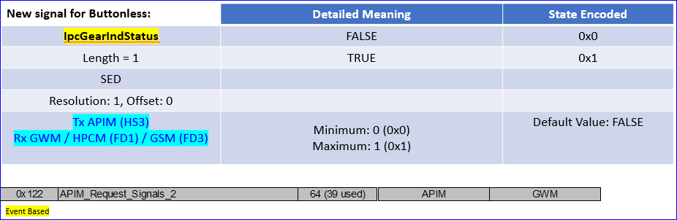

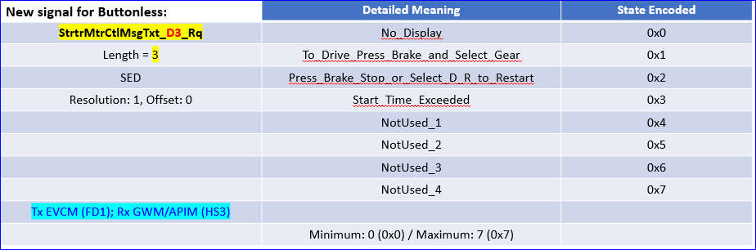

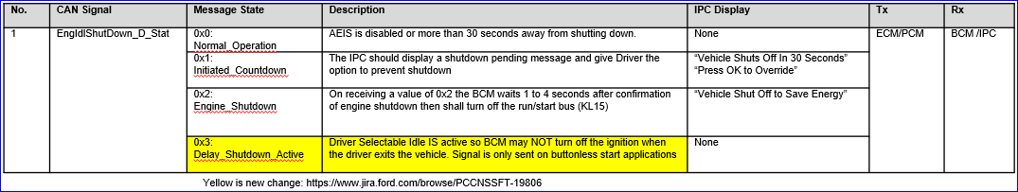

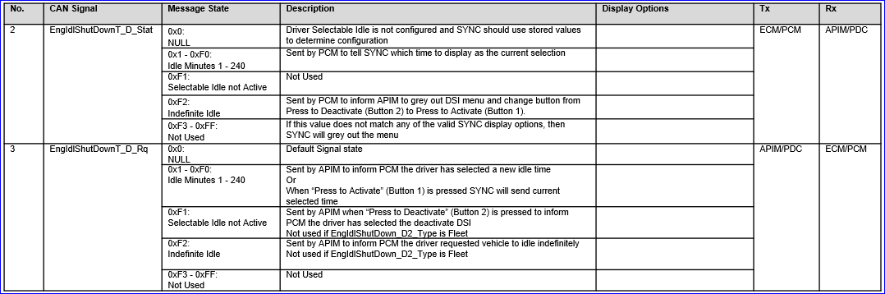

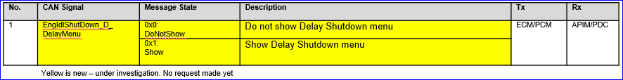

# FUNCTION SPECIFICATIONS

## Logical Function “Drive Control Optimization”

### Function Overview

#### Description

* A sequence multiple features to allow driver simplify operations to enter/exit vehicle turn on/off vechile.

#### Assumptions

No Unique assumptions for this function.

### Function Scope

Refer to BPTS and AEIS (DSIS) feature documents.

### Function Interfaces

Refer to BPTS and AEIS (DSIS) feature documents.

### Function Modeling

#### Use Cases

Refer to BPTS and AEIS (DSIS) feature documents.

#### State Charts / Activity Diagrams / Sequence Diagrams / Decision Tables

### Function Requirements

##### Normal Operation

Refer to BPTS and AEIS (DSIS) Function Requirements.

###R_F_DCO_00001### Activate vehicle authentication by PaaK

This function enables the driver to get access to vehicle through PaaK.

**Inputs:** Press button on door handle (hardwired), request PaaK proximity

**Outputs:**  Unlock vehicle for driver to enter vehicle, unlock all doors with double press button on

###R_F_DCO_00002### Detect Driver Door Ajar Switch State (Open or Closed)

This function performs detection of driver door status (open/closed)

**Inputs:** Door Ajar Switch (hardwired) state

**Outputs:**  Driver door ajar switch status open/close detected

###R_F_DCO_00003### Detect Driver Door Ajar Status change from closed to open

This function performs detection of transition of driver door from closed to open

**Inputs:** Driver Door Ajar Status Open/Closed

**Outputs:**  Driver door ajar status change from closed to open detected

###R_F_DCO_00004### Activate vehicle authentication by NFC

This function enables the Driver to get access to vehicle through NFC

**Inputs:** Driver scan NFC card at the reader provided outside the vehicle. Request vehicle authentication

**Outputs:**  Unlock vehicle for driver to enter vehicle. Start countdown for authorization time window of 30 seconds. Lock the vehicle if NFC card scanned twice at the reader provided outside the vehicle.

###R_F_DCO_00005### Activate Welcome sequence display

This function activates the welcome screen display when the driver door opens.

**Inputs:** Driver door status transition from close to open.

**Outputs:**  Welcome screens display on SYNC/HMI

###R_F_DCO_00006### Detect Driver Door Ajar Status change from open to close for more than 1 second

This function performs detection of transition of driver door from open to close.

**Inputs:** Driver door status transition from open to close.

**Outputs:**  Driver Door Ajar Status change from open to closed detected.

###R_F_DCO_00007### Activate Ignition “Run/Start”

This function activates the vehicle start upon driver door closed and a valid key detected inside the vehicle.

**Inputs:** Driver Door Ajar Status change from open to closed for more than 1 second. Key authentication (CAN message)

**Outputs:**  Ignition “Run/Start” request. HV Battery contactors Close request. Welcome screens display along with media/maps on SYNC/HMI. HVAC/Climate control to start running.

###R_F_DCO_00008### Close HV power contactors

This function closes the HV contactors for the vehicle start.

**Inputs:** Ignition “Run/Start” request

**Outputs:**  HV power to inverter

###R_F_DCO_00009### Invert HV power to LV power

This function inverts the HV power to LV power in process of closing the HV contactors.

**Inputs:** HV power to inverter

**Outputs:**  LV Power

###R_F_DCO_000010### Detect LV power bus active

This function detects the LV power bus active in process of closing the HV contactors.

**Inputs:** LV power

**Outputs:**  LV power bus status (active/inactive)

###R_F_DCO_000011### Publish Ignition Run/Start State

This function publishes the ignition status on the bus.

**Inputs:** LV power bus active

**Outputs:**  Ignition Run/Start State (ON)

###R_F_DCO_000012### Count down of NFC authorization

This function starts the count down of NFC authorization timer upon scanning the NFC card for key authentication on the exterior of the vehicle.

**Inputs:** Key authentication request (NFC)

**Outputs:**  NFC authorization count down timer 0-30 seconds. HMI to display press brake pedal to start the vehicle message.

###R_F_DCO_000013### Request re-scan NFC card

This function requests the driver to re-scan the NFC card inside the vehicle upon brake pedal press after the NFC authorization timer expires.

**Inputs:** Brake pedal press. NFC authorization time expires.

**Outputs:**  Brake pedal status. HMI to display No Key Found / Scan NFC Key to start the vehicle.

###R_F_DCO_000014### Activate Ignition “Run/Start” (Manual Start)

This function enables Driver to be able to start the vehicle manually with brake pedal press with valid key in vehicle (or) to be able to start the vehicle with NFC authentication within the authorization time window of 30 seconds after.

**Inputs:** Key authentication (PaaK or NFC) CAN message. NFC authorization count down timer. Brake pedal depressed (CAN message).

**Outputs:**  Key detected inside vehicle. NFC authorization time window. Ignition “Run/Start” request.

###R_F_DCO_000015### Release park brake

This function releases the park-by-brake upon brake pedal press and any driver range selection on the E-Shifter except “Park”.

**Inputs:** Key authentication (PaaK or NFC) CAN message. Brake pedal depressed (CAN message). Drive range selection (PRNDL-RNDL EPB integrated to “Park” position of E-Shifter) (CAN message from GSM).

**Outputs:**  Key detected inside vehicle. Brake pedal status. Park Brake Released Status (Released or Engaged).

###R_F_DCO_000016### Activate Power Pack Torque

This function enables Driver to be able to transition the vehicle to motive mode by pressing brake pedal and drive range selection.

**Inputs:** Key authentication (PaaK or NFC) CAN message. Brake pedal depressed (CAN message). Drive range selection (PRNDL-RDL EPB integrated to “Park” position of E-Shifter)(CAN message). Park Brake Released Status (Released).

**Outputs:**  Key detected inside vehicle. Activate Ignition run/start (manual start). Power pack torque available. Display the PRNDL status to the driver. Trigger ready to drive notification.

###R_F_DCO_000017### Activate Ready to drive notification.

This function triggers ready to drive notification to driver.

**Inputs:** Powerpack Torque available.

**Outputs:**  Trigger ready to drive notification on IPC.

###R_F_DCO_000018### Activate Ignition OFF

This function enables Driver to be able to shutdown the vehicle with driver door transition to close and no key detected in vehicle.

**Inputs:** Vehicle in “Park”. Seatbelt OFF (CAN message). Drive Door Ajar. No key detected.

**Outputs:**  Vehicle “Park” status. Seatbelt status. Driver Door Ajar status. No key detected inside vehicle. Request vehicle shutdown(HV contactors open).

###R_F_DCO_000019### Open HV Contacts

This function opens the HV contactors upon vehicle speed <5 kph (vehicle in “park”) and ignition off request from BCM.

**Inputs:** Vehicle speed <5 kph. Ignition OFF request.

**Outputs:**  Vehicle speed. HV Contactors open.

###R_F_DCO_000020### Activate DSI prompt

This function triggers the Drive Selectable Idle prompt on HMI.

**Inputs:** Seatbelt OFF (CAN message).

**Outputs:**  Vehicle “Park” status. Seatbelt status. DSI prompt on HMI for user to interact.

###R_F_DCO_000021### Activate Farewell sequence

This function triggers the farewell sequence display upon driver exit.

**Inputs:** Vehicle in “Park”. Seatbelt OFF(CAN message). Driver Door open.

**Outputs:**  Vehicle “Park” status. Seatbelt status. Farewell sequence triggered on display.

###R_F_DCO_000022### Engage Vehicle “Park”

This function moves the vehicle to “Park” position upon OFF button press.

**Inputs:** OFF button depressed. Vehicle speed <5 kph (CAN message).

**Outputs:**  Vehicle moves to “Park” position.

###R_F_DCO_000023### Activate Ignition OFF (Manual Shutdown 1)

This function enables Driver to be able to shutdown the vehicle manually through the optional OFF button.

**Inputs:** OFF button depressed. Vehicle speed <5 kph (CAN message).

**Outputs:**  Vehicle shifts to “Park”. Farewell sequence. HV Contactors open.

###R_F_DCO_000024### Activate Ignition Accessory Mode (Manual Shutdown 2)

This function enables Driver to be able to de-activate the powertrain manually through the optional OFF button.

**Inputs:** Depress OFF button. Vehicle speed >5 kph.

**Outputs:** Vehicle shifts to neutral and rolls freely. Powertrain de-activated with steering, braking and cluster operating normally. Activate ignition off (if vehicle speed <5 kph in the process).

###R_F_DCO_000025### Re-activate Powertrain

This function enables Driver to be able to re-activate the powertrain by drive range selection after de-activating it manually through the optional OFF button.

**Inputs:** Depress OFF button. Vehicle speed >5 kph. Depress Brake pedal. Drive range selection.

**Outputs:** Vehicle shifts to neutral and rolls freely. Powertrain de-activated with steering, braking and cluster operating normally. Vehicle shifts to selected gear and returns to normal driving behavior.

###R_F_DCO_000026### Activate Vehicle Idle

This function enables Driver to be able to idle the vehicle.

**Inputs:** Vehicle in “Park” status. Authorized key in vehicle. No action taken from user (brake pedal press, accelerator, de-activation of AEIS). De-activate AEIS to select “infinite” idle option.

**Outputs:**  Vehicle user to configure or override vehicle idle via HMI 30 seconds before the AEIS timer expires. Vehicle shut down if no input from user. Vehicle idles until the battery threshold SOC.

###R_F_DCO_000027### Activate Driver Selectable Idle Shutdown (DSIS)

This function enables Driver to be able to delay the vehicle shutdown through the pop-up from HMI.

**Inputs:** Authorized key in vehicle. DSI prompt. Driver Door Ajar. Key proximity.

**Outputs:** Vehicle “Park” status. Seatbelt status. Key detected inside vehicle. DSI prompt configuration timer menu (1-30 minutes) along with “infinite” idle option to user via HMI. Door Ajar status. No key detected inside vehicle. Idle vehicle per inside vehicle. Idle vehicle per user selection. Activate ignition off if no input from user.

###R_F_DCO_000028### DSIS using Fordpass/Lincoln way

This function enables Driver to be able to edit the delayed vehicle shutdown timer post exit after delaying the vehicle shutdown through the pop-up from HMI (Follow-up function from Activate DSIS function) – Pre-condition is Drive selects the DSIS before exiting the vehicle.

**Inputs:** Input from Phone. Data from Cloud. Configure DSI via FordPass app/Lincoln way from phone.

**Outputs:**  User configure the DSI timer from phone. User configuration from cloud to vehicle. User can exit DSI or add/remove time to delayed shutdown timer remotely using Fordpass/Lincoln way.

## Logical Function “Drive Control Optimization”

### Function Overview

#### Description

* DCO functions are captured in BPTS and AEIS(DSIS) features. Function overview refer to BPTS and AEIS (DSIS) Function Overview in their feature documents.

#### Assumptions

* No Unique assumptions for this function.

### Function Scope

Refer to BPTS and AEIS (DSIS) feature documents.

### Function Interfaces

Refer to BPTS and AEIS (DSIS) feature documents.

### Function Modeling

Refer to BPTS and AEIS (DSIS) feature documents.

### Function Requirements

##### Normal Operation

Refer to BPTS and AEIS (DSIS) feature documents.

## Logical Function “DCO”

### Function Overview

#### Description

Refer to BPTS and AEIS (DSIS) feature documents.

#### Assumptions

Refer to BPTS and AEIS (DSIS) feature documents.

### Function Scope

Refer to BPTS and AEIS (DSIS) feature documents.

### Function Interfaces

#### Logical Inputs

Refer to BPTS and AEIS (DSIS) feature documents.

#### Logical Outputs

Refer to BPTS and AEIS (DSIS) feature documents.

### Function Modeling

#### Use Cases

Refer to BPTS and AEIS (DSIS) feature documents.

#### State Charts / Activity Diagrams / Sequence Diagrams / Decision Tables

Refer to BPTS and AEIS (DSIS) feature documents.

### Function Requirements

##### Normal Operation

Refer to BPTS and AEIS (DSIS) feature documents.

## HMI Function “refer to BPTS and AEIS (DSIS) feature documents”

### Function Overview

#### Description

Refer to BPTS and AEIS (DSIS) feature documents.

### Function Scope

Refer to BPTS and AEIS (DSIS) feature implementation specification.

### Function Interfaces

Refer to BPTS and AEIS (DSIS) feature implementation specification.

#### State Charts / Activity Diagrams / Sequence Diagrams / Decision Tables

Refer to BPTS and AEIS (DSIS) feature implementation specification.

# Feature IMPLEMENTATION SPECIFICATION

## Feature Implementation Overview

Refer to BPTS and AEIS (DSIS) feature implementation specification.

### Description

-BEV, CDX 746/747 MY24

### Assumptions

1. BEV vehicle MY24 CDX 746/747

##### E/E Architecture

Refer to BPTS and AEIS (DSIS) feature implementation specification.

#### E/E Components

Refer to BPTS and AEIS (DSIS) feature implementation specification.

#### E/E Connections

Refer to BPTS and AEIS (DSIS) feature implementation specification.

|  |  |  |  |  |
| --- | --- | --- | --- | --- |
| **Connection Name** | **Type** | **Description** | **Allocated Messages** | **Connected Nodes** |
| HS3 | High Speed | High speed 3 CAN network |  |  |
| HS2 | High Speed | High speed 2 CAN network |  |  |
| HS1 | High Speed | High speed 1 CAN network |  |  |
| MS1 | Medium speed | Medium speed 1 CAN network |  |  |

Table 11: E/E Connections

#### Signal List

Refer to BPTS and AEIS (DSIS) feature implementation specification.

## Function Deployment

### Function Allocation

Refer to BPTS and AEIS (DSIS) feature implementation specification.

## Requirements

### Requirements on Components

#### Component

Module list for BPTS and AEIS (DSIS)

|  |  |
| --- | --- |
| **Module Name** | **Description** |
| EBB |  |
| BCM |  |
| PDCM/SDCM |  |
| APIM-HMI |  |
| BECM |  |
| EVCM |  |
| BCCM |  |
| RCM |  |
| BUN |  |
| TCU |  |
| ECM |  |
| PCM |  |

Refer to the feature documents in the above list.

Refer to BPTS and AEIS (DSIS) feature implementation specification

#### Inputs

Refer to BPTS and AEIS (DSIS) feature implementation specification

#### Logical Outputs

Refer to BPTS and AEIS (DSIS) feature implementation specification

#### Component

Refer to BPTS and AEIS (DSIS) feature implementation specification

#### Logical Inputs

Refer to BPTS and AEIS (DSIS) feature implementation specification

#### Logical Outputs

Refer to BPTS and AEIS (DSIS) feature implementation specification

### Requirements on Connections

###### Message List

Refer to BPTS and AEIS (DSIS) feature implementation specification

# OPEN CONCERNS

| ID | Concern Description | e-Tracker / Reference | Responsible | Status | Solution |
| --- | --- | --- | --- | --- | --- |
| 1 | Activity diagram will be added. |  |  |  |  |
| 2 | DCO State Machine diagram will be updated. |  |  |  |  |
| 3 | Impacted listed features list will be updated. |  |  |  |  |
| 4 | Signals list will be updated. |  |  |  |  |
| 5 | HMI will be updated. |  |  |  |  |
| 6 | Impacted Lock/Unlock features will be updated. |  |  |  |  |
| 7 | Impacted modules will be updated. |  |  |  |  |
|  |  |  |  |  |  |
|  |  |  |  |  |  |

Table 12: Open Concerns

# REVISION HISTORY

|  |  |  |  |  |  |
| --- | --- | --- | --- | --- | --- |
| Rev.  (revision) | Vers. | Date | Description | Approved by | Responsible |
| *001* | *A* | *2021.03.04* | *First version of DCO for UPV0* |  |  |
| *002* | *A* | *2021.05.14* | *Second version of DCO* |  |  |
|  |  |  |  |  |  |

## Template Revisions

*#Important: Do not change this section*

|  |  |  |  |  |
| --- | --- | --- | --- | --- |
| Version | Rev. | Date | Description | Responsible |
| *1* | *0* | *2016-04-07* | * *Initial version based on FDS v1.2 and Feature Doc 1.5 structure* | *Jbaden1* |
| *1* | *1* | *2016-05-10* | * *Minor rewording in ch. 1.1* * *Cleanup of document properties* | *Jbaden1* |
| *1* | *2* | *2016-06-16* | * *Lessons learned from pilots incorporated into feature and function decomposition part.* | *Jbaden1* |
| *1* | *3* | *2016-07-08* | * *Template version added to footer.* | *Jbaden1* |
| *2* | *0* | *2016-07-15* | * *Template updated according to latest Feature, Function and Platform Specification Templates* * *RE_SafetyRequirement style added* | *Jbaden1* |
| *3* | *0* | *2016-09-05* | * *Lessons learned from IPRB pilot incorporated* * *Harmonization with CV&S PRD* | *Jbaden1* |
| *3* | *1* | *2016-12-09* | * *Logical Signal and Data Types section content moved to Specification_Macros.dotm (v3.1)* | *Jbaden1* |
| *4* |  |  | *Skipped to synchronize with Specification_Macros.dotm* |  |
| *5* | *0* | *2017-01-13* | * *Meta data updated for specification macros, version 3.1* * *SW Unit chapter removed for the time being* * *Green boxes added for user hints* | *Jbaden1* |
| *5* | *1b* | *2017-01-31* | * *Some editorial corrections* * *Substructure of old Network Communication (now Connections) moved to Requirements on Connections* * *Harmonized with FIS template* | *Jbaden1* |
| *6* | *0* | *2017-04-28* | * *RequirementsTraceability chapter removed* | *Jbaden1* |
| *6* | *0* | *2018-07-18* | * *CR73: Expand ToC of AFS to level 5* * *CR63: Updated links to Functional Safety Sharepoint* * *CR74: new chapter “Safety Assumptions” added* * *CR75: Some rewording -> Terminology to Glossary, Notation -> Document Conventions* * *CR76: no longer maintain 2 different sections for configuration and for calibration parameters* | *Jbaden1* |
| *6* | *0* | *2018-08-06* | * *CR53: New non-FAP-150 cover sheet* * *CR80: Harmonize chapters of the Aggregated Feature Spec and the Aggregated Service Spec with the Function Group Spec. Each Function subsection should follow exactly the Function Spec Template* * *CR81: Incorporate lessons learned from System Service Spec pilot (Vehicle Speed) into AFS and FIS* | *Jbaden1* |
| *6* | *0* | *2018-09-28* | * *Broken links to RE Wiki repaired* | *Jbaden1* |
| *6* | *0* | *2018-10-31* | * *“Overview” and “Description” exchanged in headings* * *Some smaller modifications on cover sheet and in footer* * *Functinonal Safety alignment:*   + *New sections “Parameter / Values” on Feature level, Functional Safety Req. and (Decomposed) Functional Safety Req. added*   + *“Logical Architecture” Section removed* | *Jbaden1* |
| *6* | *0* | *2018-12-01* | * *Variant condition fields added consistently* * *Links updated* * *Background, Goals, Objectives, … removed. Left to separate document Feature Charter Document* | *Jbaden1* |
| *6* | *0a* | *2019-01-03* | * *Chapter heading “Inherited Function Requirements” removed. Corresponding table renamed to “Requirements not cascaded”.* * *E/E Connection table got another column for allocated messages* * *Naming conventions for Implemented Functions corrected (FncName_CmpName instead of FncName_on_CmpName)* * *Editorial corrections on the cover sheet* * *Explanatory text added to “Ethernet” section in chapter “Requirements on Connections”* * *AIS templates updated. Linked to Wiki page* | *Jbaden1* |
| *6* | *0b* | *2019-01-15* | * *Change: "doc acronym" and "product type" added to Word doc properties to ease spec alignment of certain capters across FIS, AFS and ASS.* * *Bugfix: table 22 renamed from FTTI table to FHT table, includes a bug fix: each FSR is allocated to only one ECU/component* | *Jbaden1* |
| *6* | *0b* | *2019-02-04* | * *Change: Chapter “Interface Requirements” added to “Implemented Function xxx” section (to have a single chapter for to collect subscriber/publisher interface and mapping requirements which to not conform to the corresponding Data Dictionary objects)* * *Change: “CAN Interface” subsection renamed to “AIS Interfaces” again. Although several Subscriber/Publisher interface attributes are probably CAN bus specific, other attributes seem to be well suited for other networks than CAN.* * *Change: Chapter “ECU Specific Requirements” renamed to “Component Specific Requirements” in chapter “Implemented Function xxx”. Table “Requirements not cascaded” renamed to “Component Specific Requirements” and refined to describe changes from Logical Function requirements set more formally. This is also to help during VSEM import to identify those requirements of the Logical Function which cannot be simply carried over to the ECU.* * *Change: Explanatory text in section “Implemented Function xxx” improved.* | *Jbaden1* |
| *6* | *0b* | *2019-02-05* | * *Change: Layout of AIS Interfaces in Data Dictionary reworked to enable Excel Import* | *Jbaden1* |
| *6* | *0c* | *2019-02-20* | * *Bugfix: AIS Interfaces tables partially formatted incorrectly (heading “Network Timing” and “Signal Integrity/Robustness” got exported for Publisher Interface). A few values formatted as invisible* | *Jbaden1* |

# APPENDIX

Document ends here